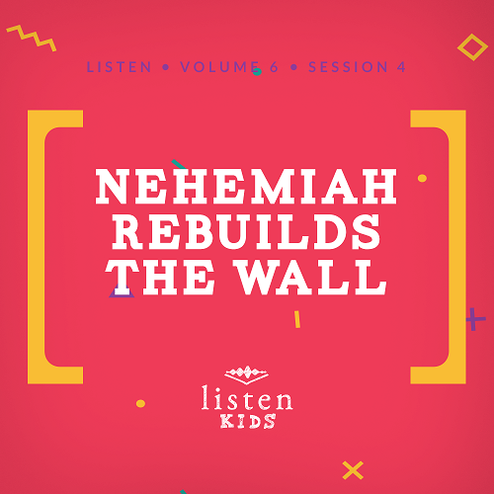Leader Overview
The Bible is often filled with stories of immediate miracles. Nehemiah shows the value of trusting God and His timing. Nehemiah understood the importance of having the support of earthly kings, local leaders, and perfect timing when it comes to sharing plans with others. Nehemiah was able to complete an incredible building project and continue the restoration of Jerusalem by trusting God. When I trust God, He helps me get through every situation.

Bible Lesson
Nehemiah Leads the People
Nehemiah 2:11–20
Faith Fact
God wants me to trust Him.
Faith Verse
2 Corinthians 5:7 (NLT)
For we live by believing and not by seeing.

Preparing for the Session
Leader Preparation Time: 20–25 Minutes
You Will Need
Large Group
- Bible
- Worship songs (Song suggestions: “All of Me” by Gateway Kids Worship; “This Is Amazing Grace” by Bethel Music Kids; “It’s Your Love” by Gateway Kids Worship)
- For groups not using a phone or tablet only, add:
• Projector or TV
• Laptop
• Countdown60 Video–60 seconds
• Rules Video or Slide
• Faith Fact Slide
• Faith Verse Video or Slide
• Bible Lesson Video A
• Bible Lesson Video B
• Bible Lesson Slide 1
• Cups, at least three per kid
• Tape to mark start and finish lines on the floor
Small Group
• Small Group Activity Page 1, one per kid
• Small Group Activity Page 2, one per seven kids
• Small Group Group Connection
• Scissors, one pair per kid
• Glue or glue sticks
• Crayons, colored pencils, or markers

To download session videos, slides, and printables, visit: BibleEngagementProject.com/downloads

Getting Ready
Large Group
- Download videos and slides if needed.
- Select worship song(s) and have them ready to play.
- Mark start and finish lines with tape.
Small Group
- Print the Small Group Activity Page 1, one per kid.
- Print the Small Group Activity Page 2, one per seven kids.
- Cut the strips of the Faith Fact from the Small Group Activity Page to give to the kids.
- Print and cut out the Small Group Group Connection photos. Then, hide them around the room.

First time leading Listen for Kids? Check out the Facilitator Guide.

Large Group
30 Minutes
See what’s needed at the beginning of the session.

Introduction
We are so glad you are here! Today in our Bible story, we are taking a trip to a construction scene. I am curious what kind of construction projects you have seen being built. A house? A tall building? A road? A bridge or overpass? A fence or a wall? Our Bible story is going to be part of a major building project.
I don’t know about you, but sometimes when I look at something being built, it doesn’t make sense to me. I can’t see, or visualize, what it is going to look like when it is finished. How can a couple of beams coming out of the dirt ever become this beautiful three-story hotel? But it can. There are plans and a bunch of different pieces, and if you trust the process, everything turns out okay.
It’s the same way in our lives. We don’t always know what the end is going to look like, but we know that God does.
• Show the Faith Fact Slide.
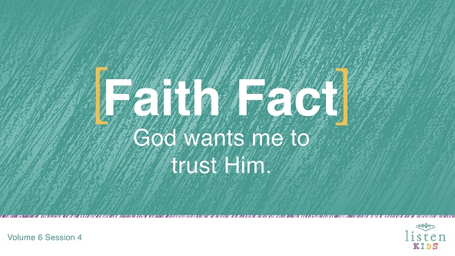
Let’s take a look at our Faith Fact and say it together. God wants me to trust Him.
This time when we say it, let’s hit our fist to our hand like a hammer on each word. One more time! God wants me to trust Him. Great job!
Rules Review (Optional)
Now on a construction site there are lots of rules, such as always wear a hard hat and stay out of the path of moving vehicles. Well, we’ve got some rules to follow while we’re here. Let’s take a look at them now.
• Play Rules Video.
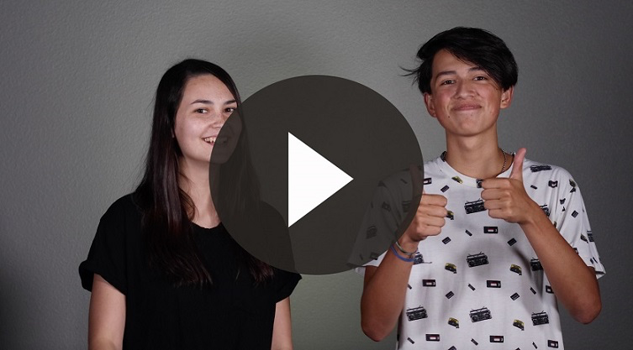

Game
Build a Wall
You Will Need
- Cups, at least three per kid
- Tape to mark start and finish lines on the floor
- Countdown60 Video–60 seconds
Getting Ready
- Tape a start and finish line on the floor

We are going to build a wall. We’re going to divide into two teams. Each team will run a relay to stack their cups and build a wall. The goal is to build the biggest wall.
One person on the team will run and set a cup down. The next person runs and sets a second cup down either beside it or stacked on it. At the end of sixty seconds, whichever team has the bigger wall with the most cups wins. Are you ready? Ready, set, go!
• Play the Countdown60 Video.
• Clap for the winning team.
Now that was fun! Did you notice everything has to be just right for the cups to stand? Today, we are going to look at a man in the Bible who helped to rebuild the gates and wall of a city. His name was Nehemiah. Before we hear more about him, we’re going to worship by singing. Get on your feet. Here we go!

Worship
There are lots of ways to worship God—praying, singing, raising our hands, bowing, and more. I love to sing when I worship. Let’s worship Him together.
• Lead the kids in singing one or two praise songs. See suggestions at the beginning of the session.

Bible Lesson
I love worshipping, and I know God loves it when we sing to Him like that. Let’s bow our heads and pray together.
Prayer
Dear God, thank You for loving me. I know I can trust You in every situation. You will always be with me and never leave me. Thank You, God. Amen.
Video Intro
We have a lot to do today, but before we get started with the Bible story, let’s check in with the Challenge Accepted team and see what they’re up to!
• Play Bible Lesson Video A.
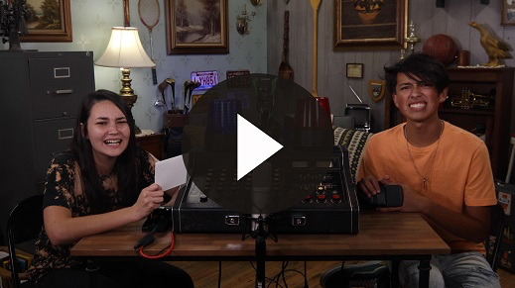
That was incredible! Would you want to accept that challenge? (Group response) Then let’s move to our Bible story.
Bible Story
We are going to the Book of Nehemiah today. (Open Bible to Nehemiah)
So far, we’ve learned about how the Babylonians destroyed Jerusalem and took a bunch of the people away to Babylon. Next, the Babylonians were defeated by the Medes and Persians. Then, Queen Esther came along and saved the Jews. Do you remember all of that?
Well, not everyone was a captive in the foreign land. In fact, there was a whole group of people who still lived in Jerusalem. Most of the city had been destroyed, and the wall around the city was torn down completely. It wasn’t safe to live there, but many people still did.
Today, we will be learning that God wants me to trust Him through the life of Nehemiah. He was the cupbearer for the king of Persia. Does anyone know what that means? (Group response) That means that the King of Persia trusted Nehemiah with his life.
The cupbearer held a respected position because he made sure that drinks served at the royal table were safe. Back in those days, kings could have a lot of enemies, and one way to kill the king was to poison his drink. Nehemiah was responsible to make sure this never happened. Sometimes he had to put his life on the line by trying the drink before the king.
Nehemiah was in the king’s winter palace in Susa, which was about nine hundred miles from Jerusalem. He had heard from one of his brothers how badly the city’s gates and wall needed to be repaired. Nehemiah’s heart was broken. He cried and went without eating for days because Jerusalem was in ruins.
Nehemiah may have never even been to Jerusalem. God was working on Nehemiah’s heart because He had a special job for Nehemiah to do.
Later, Nehemiah was in the king’s presence, and he was still upset. Have you ever been upset about something for months before? (Group response) That’s a long time to be upset. It was obvious to the king, and he asked Nehemiah why he was upset.
Nehemiah was terrified. He explained how Jerusalem was destroyed, but he knew he could have been in trouble with the king just for being sad in his presence. Instead of being mad, the king asked how he could help Nehemiah. He even gave him time off, letters to help his journey, and all the supplies he needed to rebuild the wall.
Nehemiah set off to Jerusalem with the blessing of the king of Persia. The king sent along soldiers to protect Nehemiah and those traveling with him. The nine hundred-mile journey to Jerusalem probably took them several months.
When Nehemiah arrived in Jerusalem, he didn’t tell anyone what he was doing there for three days. What do you think he was doing? (Group response) Let’s find out and read Nehemiah 2:11–12.
• Read or have a kid read Nehemiah 2:11–12.
Nehemiah quietly traveled all around the city to look it over. He found a broken wall, burned gates, and rubble so deep he couldn’t even get over it with his donkey. He then went back to the city to talk to the leaders. Let’s read what he said in Nehemiah 2:17.
• Read or have a kid read Nehemiah 2:17.
Then, Nehemiah told them about how the king had been gracious and given them not only his blessing to rebuild the wall but the needed supplies as well. The people were excited! They cheered and shouted to rebuild the walls.
But, there were a few people who didn’t like the idea. These were people who were not Jews, but they wanted to control what happened in Jerusalem. They accused Nehemiah of going against the king. They didn’t like the change that Nehemiah wanted to do, and they didn’t like that he was in charge.
The task in front of Nehemiah and the people of Jerusalem was huge! It seemed like it was impossible, but Nehemiah trusted God. He was so confident that God would help them that he told the critics that the God of heaven would help them succeed.
Nehemiah had challenges along the way. There were times that his life was threatened. At times, the people had to build using only one hand while holding a weapon in their other hand. They worked hard, and within fifty-two days, they had the wall completely done. No one expected that. Even though their enemies wanted to stop them, they trusted God.
• Show Bible Lesson Slide 1.
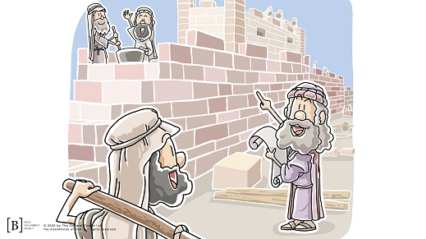
Teaching Time
For the next twelve years, Nehemiah governed Jerusalem. He not only built the wall and kept the city safe, but he also brought the people back to God by reminding the people about God’s law. God wants us to trust Him with the problems we face and every other part of our life.
Nehemiah knew it was important to stay focused on what God wanted him to do. You will probably never build a wall around a city. However, you will be challenged to do something that God wants you to do, and there may be people who tell you not to do it.
You have to make a choice. No matter how hard it may get, we know we can trust God no matter what. When we follow His direction, He will help us and provide the things we need. We just need to put our trust in God.
Faith Verse
Just like Nehemiah trusted God, we need to remember that God wants me to trust Him. When I learn God’s Word, it will come to my mind when I have doubts that I can trust Him. It isn’t because of what I see happening around me, but it’s based on what I believe. Let’s do the actions together as we say the verse.
• Play Faith Verse Video.
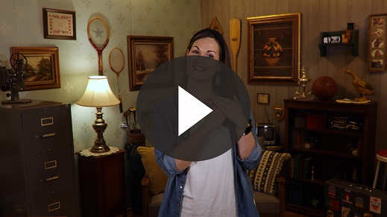
2 Corinthians 5:7 (NLT)
For we live by believing and not by seeing.
When we can’t see the outcome or what is going to happen, we have to have faith. We have to believe that God is going to make it all work out. We have to remember that God wants me to trust Him.

Prayer and Response
Consider playing a worship song softly in the background while kids pray.
We are going to take a couple of minutes and let God talk to us. Praying is having a conversation. I talk to God, and then I listen. I know He is speaking to me when I feel a certain impression or thought. He may bring to my mind a particular situation or a person that I wasn’t thinking about before.
Today as we pray, we are going to ask God to speak to us, and then we are going to listen to what He says. Find a spot to sit and listen to God without anyone too close to you. Then, ask God what is the one thing that you need to know you can trust Him about today. Then, listen.
• Give kids time to pray. Then introduce the worship song. This could play in the background while kids pray or could be a worship song to sing together.
Worship Song
Play a worship song.
Video Wrap-Up
That was a great prayer time. Now let’s see how the Challenge Accepted team’s challenge worked out.
• Play Bible Lesson Video B.
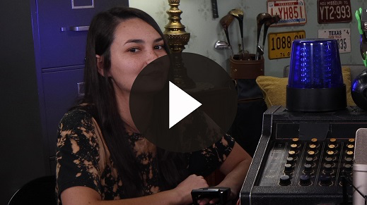
Let’s all choose to trust God like we were challenged to do. Sometimes it can be hard, but that is why we need to remember our Faith Fact.
• Show the Faith Fact Slide.
Say it with me. God wants me to trust Him. Can you trust God? Yes! Then let’s say it again as loud as we can. God wants me to trust Him.
• Dismiss kids to Small Group time or to go home if your group time ends here.

Small Group
30 Minutes
This section can be done in conjunction with the large group, or on its own if you do small groups with your kids. During Small Group time, the goal is to connect the kids with the Word of God and to each other. All activities are led by the small group leader.

Group Connection
Search the City
You Will Need
- Small Group Group Connection
- Scissors
Getting Ready
- Print and cut apart the Small Group Group Connection photos. Then, hide them around the room.

Everybody choose a partner. You and your partner will search the room just like Nehemiah searched the city of Jerusalem. He went out at night and didn’t tell anyone what he was doing. In the Bible, it told us that there were three things Nehemiah found: rubble, burned gates, and broken walls.
In this room there are six signs. You and your partner are going to be like Nehemiah and explore the room. Find the signs, but leave them where they are. Don’t tell anyone else where to find the signs. Come back to your seats as soon as you find all six signs. Remember, don’t tell anyone until the time is right.
All right, who can point to the different signs? (Have different pairs point out individual signs.) Great job of searching out the rubble, burned gates, and broken walls.

Bible Lesson Recap
You Will Need
- Bible, one per kid

No prep needed for this activity.

Bible Story Review: Nehemiah 2:11–20
Today, we heard about Nehemiah rebuilding the wall, but let’s investigate a little more. We are going to read our Bibles and see what it says about the fact that God wants me to trust Him. Turn to the Book of Nehemiah, and let’s break up this story into sections to read.
• Divide the Bible reading into smaller chunks for kids to read aloud.
This passage does a great job of showing the challenges that Nehemiah had to face and giving hints to what was going to happen in the chapters ahead. Nehemiah had to choose to trust God.
Faith Fact
Just like Nehemiah had to have faith to trust God, we need to do the same. That’s why our Faith Fact for today is God wants me to trust Him.
• Show the Faith Fact Slide.
Say it with me. God wants me to trust Him. Let’s whisper it like we’re out with Nehemiah at night, quietly searching the city of Jerusalem. God wants me to trust Him.

Group Discussion
Feel free to use all or just a few questions as a jumping-off place for good discussion. Questions marked with * are designed for more conversation. Adjust the questions based on the age or maturity of your group. Typically, older kids will be able to dive a little deeper than younger ones.
Questions
What was Nehemiah’s reaction when he heard about the state of Jerusalem?
How long was the trip from Susa to Jerusalem?
How do you think Nehemiah felt when he arrived in Jerusalem?
Today’s Faith Fact is God wants me to trust Him. What does that Faith Fact mean to you?
How did Nehemiah respond when people tried to discourage him?
* Have you ever helped with a project around the house or with your family or friends that seemed like more than you could ever complete? Who can tell us about one of them? Do you think Nehemiah felt like this might be a bigger project than anyone could ever finish?
There were two different responses when Nehemiah shared his plans. Why do you think that happened? What were the responses?
Often, there will be people excited about what God has told you to do and people who aren’t excited. How do you need to handle the situation when that happens?
How does the story from today link to the Faith Verse we have been working? Do you have to trust God when you are in the believing part of an experience or the seeing part? Seeing is easy; when you can’t see it, you just need to trust God.
* What do you think God wants you to trust Him with right now? Do you think that is going to be easy or hard to trust God through it?

Application and Response
Nehemiah was passionate about fixing his city, and God gave him everything he needed to accomplish the task. Even when certain people tried to sway the opinions of the rest of the people, Nehemiah trusted God. I know that when God has directed me to do something, I need to trust Him also. God wants me to trust Him.
Nehemiah spent time praying and working through a plan before he went forward. He realized that when he walked at God’s pace that God took care of him. The city’s wall was finished faster than anyone would have ever imagined. I need to trust God the same way that Nehemiah did because God’s plans are best.
Make It a Habit
Select a simple visual reminder of the session’s Faith Fact.
We can make it a habit to remember what we’ve learned about God today. For example, this week if God impresses on you to do something or someone asks you to do something, make it a habit to say yes instead of questioning. It will help you begin the process of trusting God.
What should we do to remember to trust Him in those cases? (Allow response)
• Make notes of what the kids share.
Prayer
Let’s pray and ask God to help us.
Thank You, God, for showing me over and over again in the Bible and in my life that I can trust You. Help me to be like Nehemiah and not let others distract me from what You want me to do. Amen.

Faith Verse Review
No prep needed for this activity.
Our Faith Verse for today is 2 Corinthians 5:7. It takes faith in order to truly believe that God wants me to trust Him. Our Faith Verse helps us understand what faith is. Let’s say the Faith Verse and do the actions for the verse together.
• Show the Faith Verse Slide.
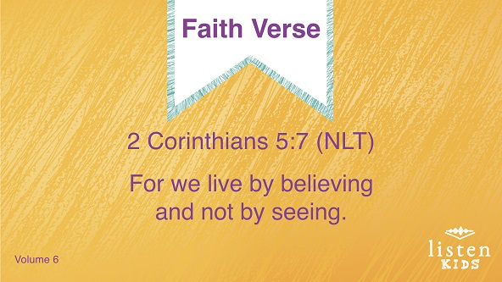
2 Corinthians 5:7 (NLT)
For we live by believing and not by seeing.
Faith Verse Fun
Cheer Squad
You have done a great job learning this verse! Today, as we talked about trust, I was thinking about people on a cheer squad. You know the ones I’m talking about. They hold their teammates in the air as they are doing cheers. The person being held up has to have a lot of trust in those holding them up in the air. We aren’t going to hold people up in the air or make a human pyramid, but we are going to do some cheers.
Cheer squads are known for using their arms to make letters. Can we all make a T for the word trust? Now let’s get creative and create a letter or action for each word of our Faith Verse as if we were on a cheer team. (Kids can make it as simple as using the letter C for Corinthians. Let them be creative; they may surprise you.)
2 Corinthians 5:7 (NLT)
For we live by believing and not by seeing.
Great work on this! You kids could start your own cheer squad. Let’s do it one more time together. (Give kids time to do the Faith Verse again as a cheer.)
2 Corinthians 5:7 (NLT)
For we live by believing and not by seeing.

Creative Activity
Wall Construction
You Will Need
- Small Group Activity Page 1 one per kid
- Small Group Activity Page 2 one per seven kids
- Scissors, one pair per kid
- Glue or glue sticks
- Crayons, colored pencils, or markers
Getting Ready
- Print the Small Group Activity Page 1, one per kid.
- Print the Small Group Activity Page 2, one per seven kids.
- Cut apart the strips of the Faith Fact from the Small Group Activity Page to give to the kids.

You have two pieces of paper today. The first has a brick wall that needs you to fill in the holes with bricks. Cut out the bricks from the small strip of paper and glue them in order in the black rectangles to complete the repair of the wall. While you are coloring the page, think about all the ways that God helped Nehemiah rebuild the wall.
Prayer
Dear God, Thank You for giving me the faith to trust You in every situation. I love and trust You. Amen.

Faith Fact Recap
• Display the Faith Fact Slide as parents are coming into the room.
• Maximize the time you have with your kids, so that parents see what their kids have learned. Have the kids repeat the Faith Fact, and then dismiss them to their parents.
Today, we learned how Nehemiah trusted God. One of the most important things that I can remember is God wants me to trust Him. Say it with me.
• Show the Faith Fact Slide.
God wants me to trust Him. Great job!

Dismissal
• Send home the Small Group Activity Page 1.
• Remind parents that there are Family Devotions available on the app to do with their kid.
• Tell everyone the date and time for the next session.

